April 2022

Dear Parent/Carer

Reception Starters – Carter’s Charity Primary School - September 2022

Milk4Life is the chosen milk supplier for providing a daily drink of milk in school. Milk is provided in individual poly bottles with a paper straw so we can support your school’s recycling project.

Under 5’s are provided with a daily drink of milk through school which is free under the NMRU scheme. To register your child for this please log on and register through [www.milk4life.com](http://www.milk4life.com)

Click on the 'parents' tab, register your details with us and you and your child will be ready for milk to start in September.

Once your child turns 5, there is a small nominal amount to pay per half term in advance for your child to continue to have a daily drink of milk each day. Please see website for up to date costs per half term.

By participating in a milk scheme at school, you are helping to give your child part of their daily calcium requirements needed to build strong bones and of course milk has many other nutritional benefits such as a broad range of essential minerals, a wide range of vitamins and is a great source of body-building protein and energy.

No other drink delivers such a nutritional package. Milk is natural with no additives and is also safe for teeth. Dentists and dietitians agree that the safest drinks for children between meals are milk and water.

If you need anything further, please contact Sarah on 01443 742112.

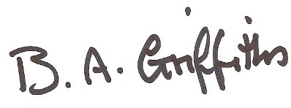

Yours sincerely

Barbara Griffiths

Milk4Life Ltd

G20 Ty C

Registered No. 8354385